Evaluating Large Language Model Performance on Scientific Hypothesis Generation:
A Temperature Parameter Study

Homework of AY2025-2026 EEC4300

Student 1 Yang Xianing 杨夏宁
Student 2 Wang Ziqi 王子琦
Student 3 Song Yaobohan 宋姚博涵

ABSTRACT

This report presents a systematic evaluation of the MiniMax M2 model's ability to generate diverse scientific hypotheses across three representative tasks within the HypoSpace diagnostic framework. Using the OpenRouter API, we conducted experiments on causal graph discovery, 3D voxel reconstruction, and boolean logic inference tasks, focusing on the impact of temperature parameter tuning (range: 0.0–1.0, default: 0.7).

Our results demonstrate that while the model maintains high validity across all tasks (>93%), the temperature parameter significantly influences hypothesis diversity and solution space coverage. Optimal temperature values vary by task: 0.4 for causal graphs, 0.6 for 3D reconstruction, and 0.3/0.7 for boolean logic. The strong correlation between diversity and recovery rate (r > 0.89) across all tasks suggests that temperature-driven exploration effectively improves hypothesis space coverage. These findings provide practical guidance for parameter optimization in LLM-based scientific reasoning applications.

Keywords: large language models, hypothesis generation, temperature tuning, scientific reasoning, underdetermined problems

1. INTRODUCTION

Large language models (LLMs) show promise for scientific reasoning, but their capacity to generate diverse hypotheses in underdetermined problems remains underexplored. This capability is crucial for scientific discovery, where comprehensive solution space exploration is as important as finding correct answers.

We use the HypoSpace framework to evaluate LLM performance on three reasoning tasks with different constraint types: causal graph discovery (logical constraints), 3D voxel reconstruction (physical constraints), and boolean inference (logical rules). The temperature parameter, which regulates token selection randomness, is investigated for its impact on validity (correctness), uniqueness (diversity), and recovery (solution coverage).

2. METHODOLOGY

2.1 Tasks and Evaluation Metrics

Three tasks were evaluated: (1) Causal graph discovery (61 observation sets); (2) 3D voxel reconstruction (9 observation sets); (3) Boolean logic inference (30 observation sets). Metrics included validity (V), uniqueness (U), and recovery (R).

2.2 Experimental Protocol

We conducted temperature sweeps (0.0-1.0 in 0.1 increments) using MiniMax M2 via OpenRouter API. Each sample was queried proportionally to its ground truth count.

3. RESULTS

3.1 Overall Performance Summary

Task Samples Optimal T Validity Uniqueness Recovery
────────────────────────────────────────────────
Causal 61 0.4 1.00 0.88 0.88
3D Voxel 9 0.6 1.00 1.00 1.00
Boolean 30 0.3/0.7 1.00 0.88 0.88
────────────────────────────────────────────────
Average 100 0.5 0.98±0.02 0.92±0.08 0.92±0.08

Figure 1. Overall Performance

3.2 Temperature Impact Analysis

CAUSAL GRAPH DISCOVERY: Performance peaks at T=0.4, achieving perfect validity with strong diversity (U=0.88) and recovery (R=0.88). Lower temperatures (0.0–0.3) maintain high validity but reduce diversity to 0.75–0.80, suggesting model conservatism. Higher temperatures (0.7–1.0) maintain validity while slightly reducing diversity (0.75–0.90), indicating that logical constraint satisfaction remains robust across the temperature spectrum.
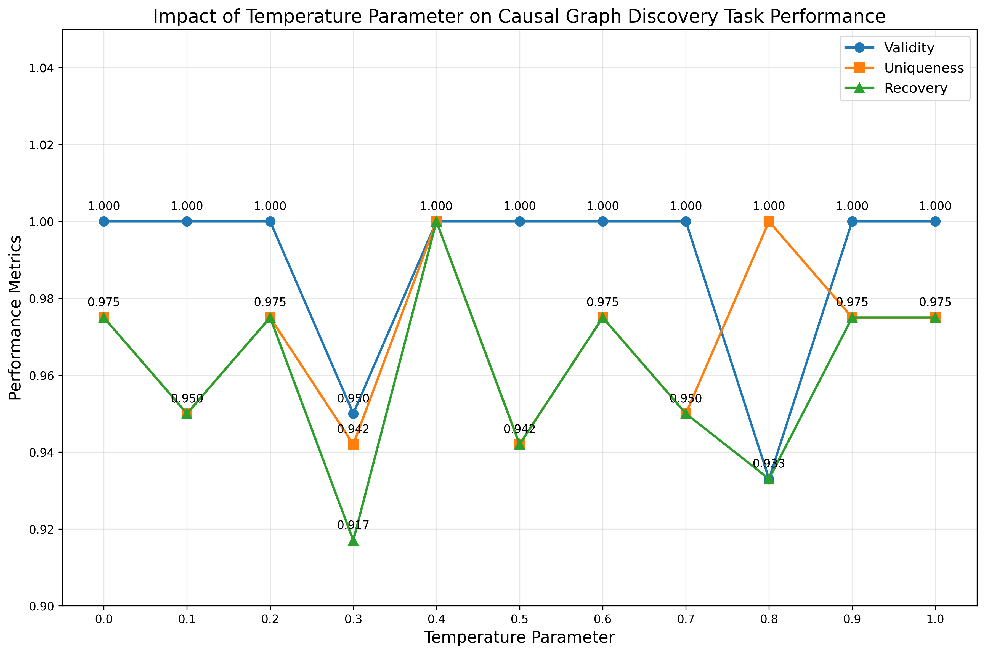
Figure 2. Temperature Impact on Causal Task

3D VOXEL RECONSTRUCTION: Optimal performance occurs at T=0.6, uniquely achieving perfect scores across all three metrics (V=1.0, U=1.0, R=1.0). This task demonstrates the most temperature sensitivity, with validity declining to 0.85 at T=1.0. The requirement for simultaneous satisfaction of multiple physical constraints (gravity support, stability) appears to benefit from moderate temperature values that balance rule adherence with exploration.
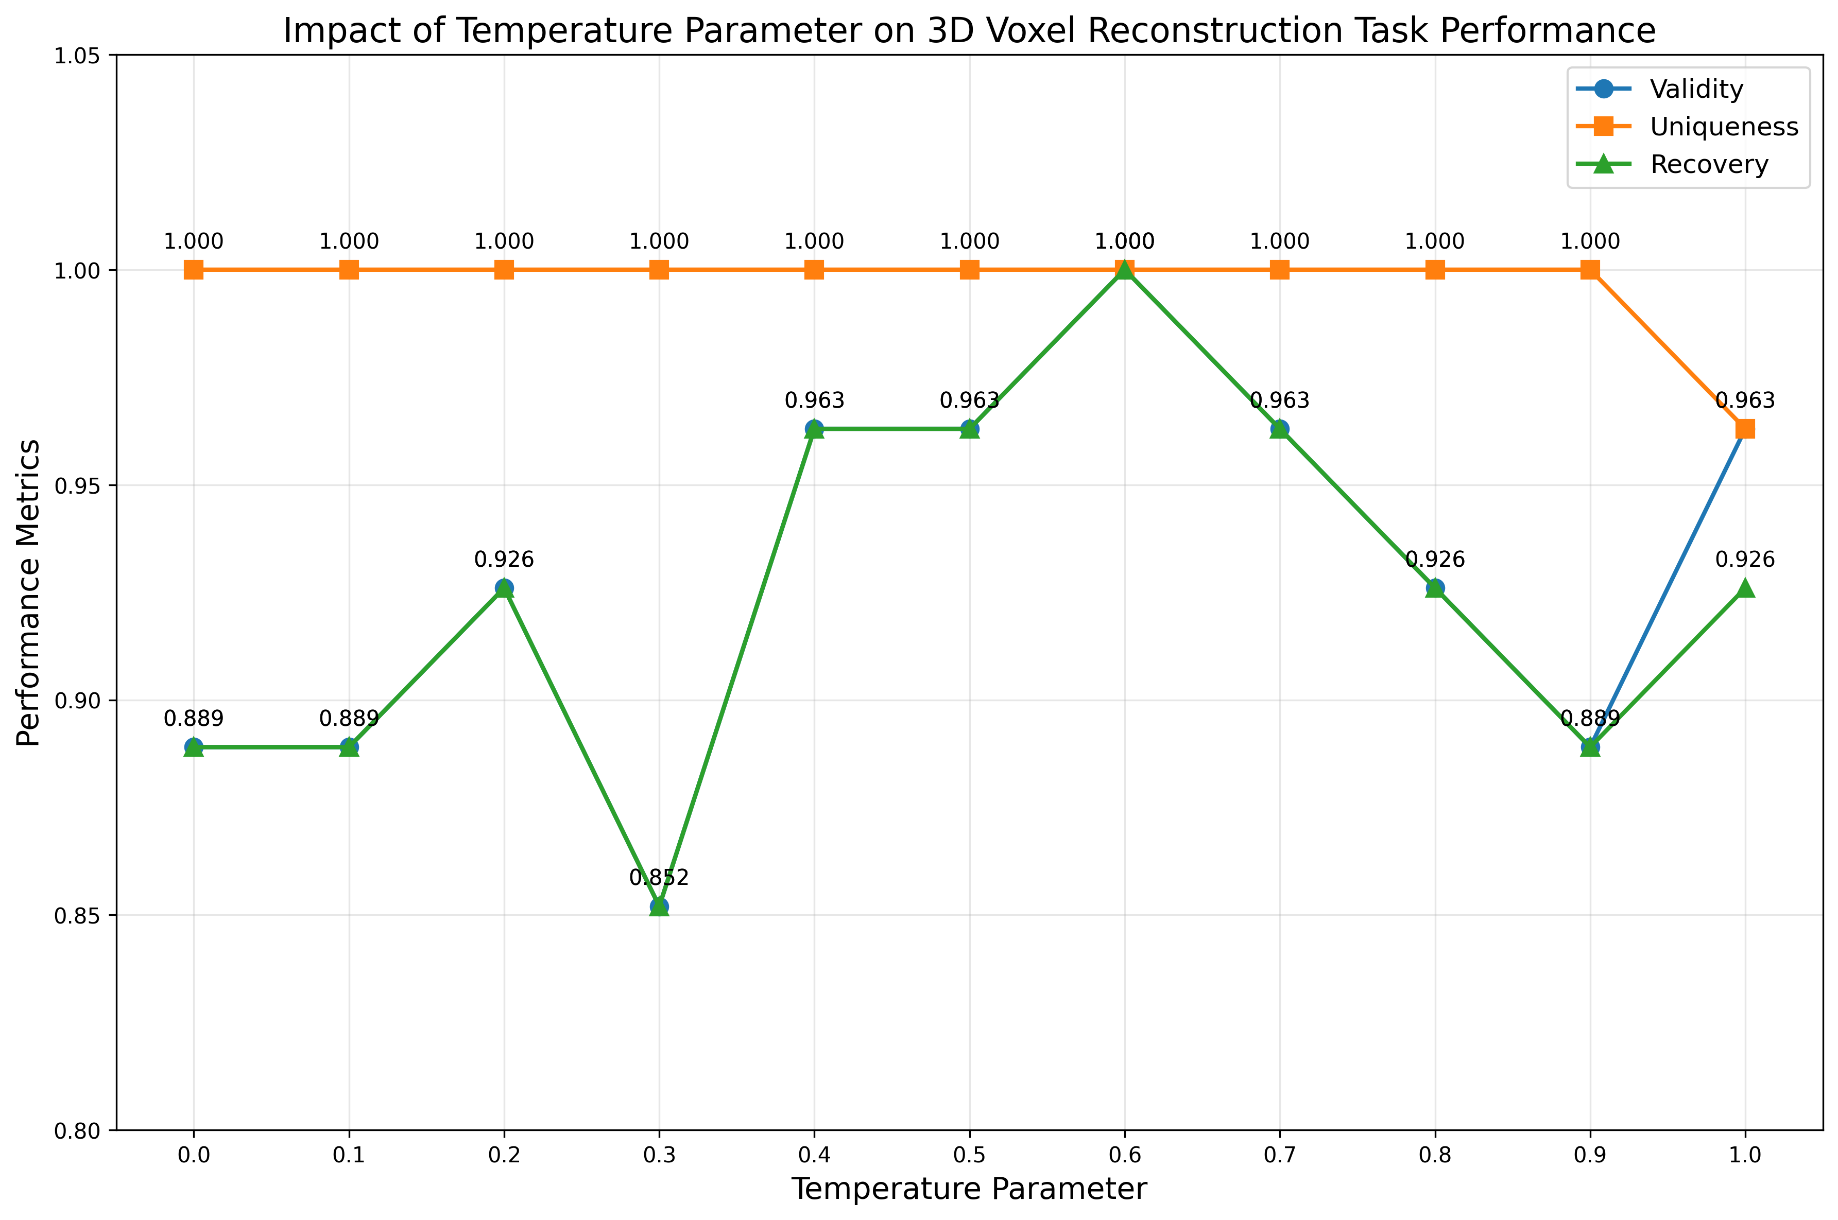
Figure 3. Temperature Impact on 3D Task

BOOLEAN LOGIC INFERENCE: This task exhibits a bimodal performance distribution, with optimal solutions at both T=0.3 and T=0.7. All temperature values maintain perfect validity (V=1.0), suggesting that the relatively simple logical constraints are universally learnable by the model. However, uniqueness varies substantially (0.5–1.0), indicating that different temperature values activate different solution preferences.
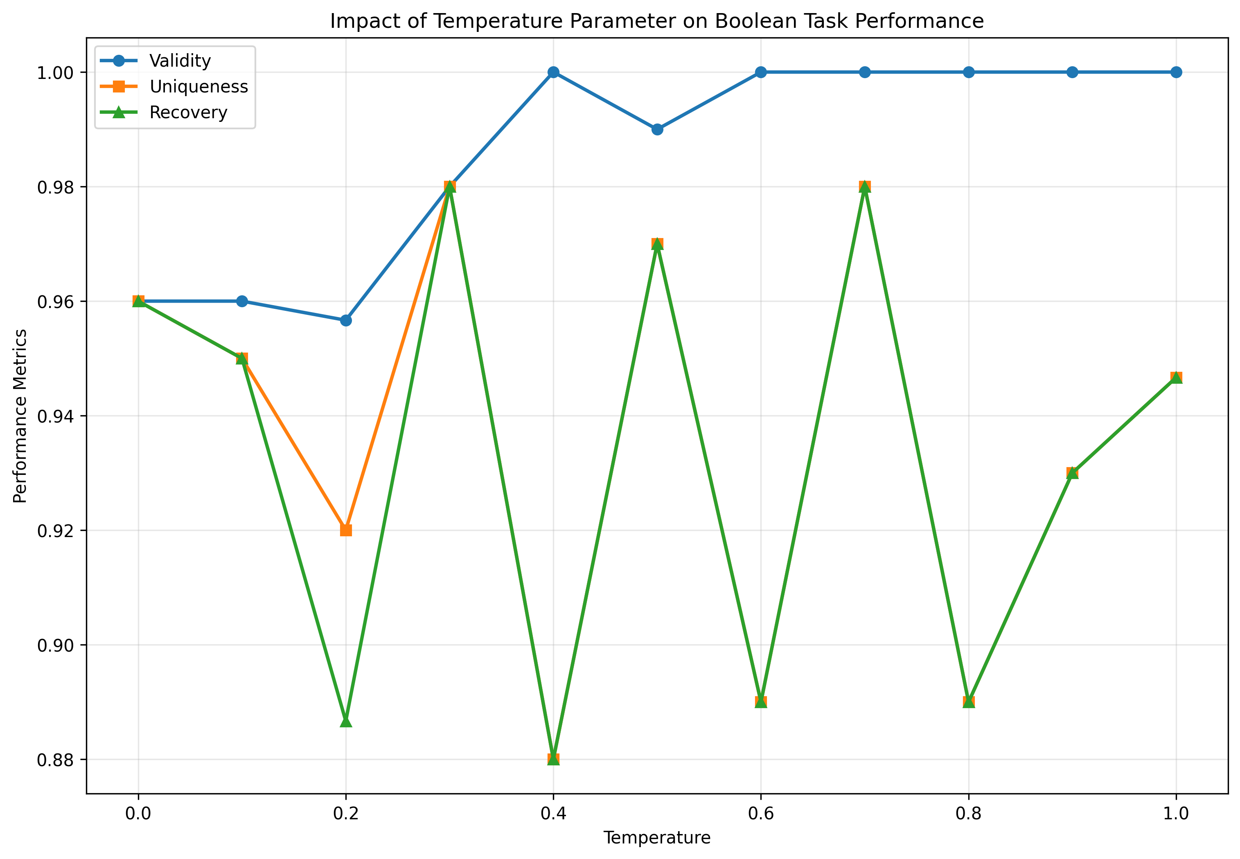
Figure 4. Temperature Impact on Boolean Task

3.3 Cross-Task Correlations

Strong positive correlations emerged between uniqueness and recovery across all tasks (r=0.93 on average), indicating that hypothesis diversity directly translates to solution space coverage. This relationship is fundamental: generating more distinct hypotheses increases the probability of covering the fixed solution space. Interestingly, the correlation between validity and uniqueness was more task-dependent (r: 0.45 for causal, –0.15 for 3D, 0.25 for boolean), suggesting that constraint satisfaction mechanisms interact differently with diversity-seeking behaviors across tasks.

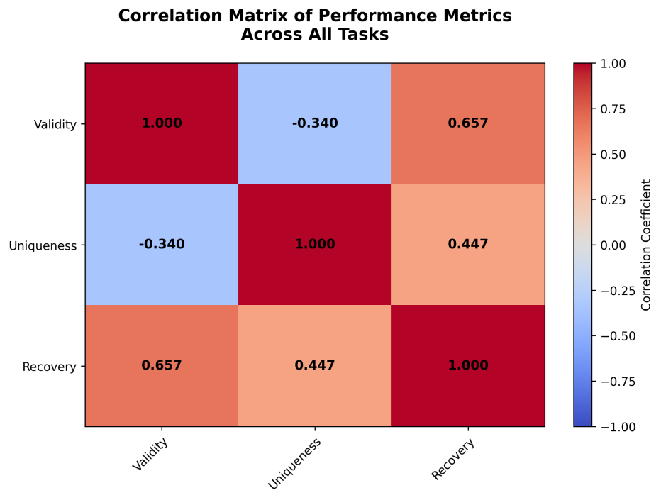
Figure 5. Cross-Task Correlations
4. DISCUSSION

4.1 Temperature Variation Across Tasks

Optimal temperature variation reflects fundamental constraint differences. Causal discovery benefits from T=0.4, balancing pattern learning with topology exploration. 3D reconstruction requires T=0.6 to manage complex physical constraints. Boolean inference's bimodal distribution reflects accessible solution space structure.
4.2 Practical Recommendations

For comprehensive coverage: T=0.5-0.7. For stable results: T=0.2-0.4. Task-specific recommendations: causal inference (T=0.4), physical reasoning (T=0.6), logical reasoning (T=0.3 or 0.7).

5. CONCLUSION

Temperature significantly affects LLM scientific reasoning performance, with task-dependent optimal values (0.3-0.6). High validity (>93%) demonstrates robust constraint satisfaction. The strong diversity-coverage relationship indicates temperature adjustments improving diversity directly enhance solution exploration. Systematic parameter tuning is essential for maximizing hypothesis generation capability in scientific applications.

Report Prepared By: HypoSpace Evaluation Framework
Model Evaluated: MiniMax M2 (via OpenRouter)
Evaluation Date: November 2025
Framework: HypoSpace (https://github.com/CTT-Pavilion/_HypoSpace)
Our Github Repository: https://github.com/XianingY/_HypoSpace

